**The Added Effect of a Pitch Timer in Baseball**

Baseball Track

Daniel Cook

**Introduction**

In 2021, the Low-A (A+) West Division within Minor League Baseball (MiLB) began implementing a "Pitch Clock Timer" during the fifth week of the season with specific rules to help speed up Baseball games which had average game times of over 3 hours. In 2023, MLB began implementing the pitch timer rules used by the A+ MiLB, resulting in a decreased average of 28 minutes played per game. This paper uses a Differences-in-Differences (DID) model to show whether the PitchTimer affects variables other than time in the game. Specifically, does the PitchTimer increase the Batting Average of a hitter?

**Data**

The study population is A+ MiLB Batters who are qualified (have at least 123 at-bats per season) between 2015-2022. The response variable is the Batting Average, the ratio of hits to official at-bats. An official at-bat excludes walks and when a pitch hits a batter. The explanatory variables are Year, measured in 20XX seasons; PitchTimer, measured by whether the game used a PitchTimer; and Year*PitchTimer, explaining the effect on the PitchTimer over a MiLB season.

**Methods**

Batting Average = B0 + B1Year + B2PitchTimer + B3Year*PitchTimer

Batting-average (BA) is the Player's ratio of the number of hits per official at-bat. Year is the season surrounding games played between 2015-2022. B1 is the change in BA for a one-year increase in time. PitchTimer (PT) indicates whether the batter in the A+ MiLB league was in the A+ West (1) or in another A+ Division (0). B2 compares the population's BA with a PT versus those without a PT. B3 shows the effect a PT has on BA based on the Year. The multiple regression data and results are as follows:

**Results**

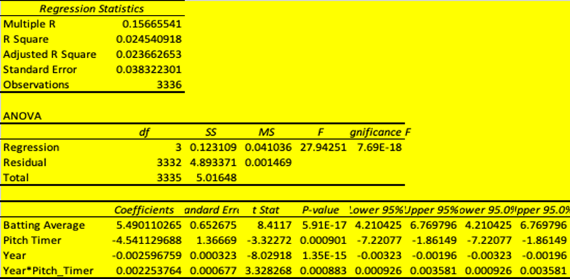

A population of 3,336 A+ MiLB Player Batting Statistics from 2015-2022 (Year) represented the data to conduct a multi-regression on the PitchTimer (PT) effect on BA. The overall BA for the data is .250. There is a relatively low R-square of .0245, with the model explaining approximately 2.45% of the overall variance. Year*PitchTimer is the parameter of interest and provides strong significance based on the P-value of 0.000883.

Moreover, the Year*PitchTimer coefficient provides a positive coefficient of 0.002253, suggesting a correlation between a PT and a higher BA. In 2015-2019 data, results showed a higher BA in A+ West versus the other A+ Divisions by 1.24%, and between 2021-2022, BA for the A+ West was 7.84% higher. The model below visualizes the DID model explained above and summarizes data from 2015-2022:

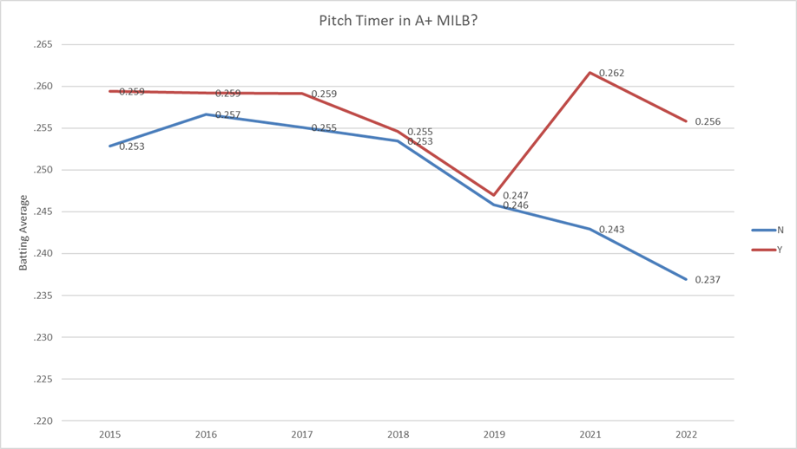

**Conclusion**

There is a direct and significant relationship between a player’s BA and the use of a PT. Although open-source information supports the positive relationship between a player's BA and the use of a PT, there are only two and a half years of MiLB data on the topic, and limited datasets and information on MiLB rules prevent the ability to make any such conclusion definitively.

**References**

<https://www.rotowire.com/baseball/stats-minors.php>